1. Introduction

Project Title: LearnHub:Your Center for Skill Enhancement
Team Members:

Gavini Venkata Murali Krishna

Deepika Mukku

Darsi Balaji

Darla Sandhya

2. Project Overview

Purpose:
To build a responsive, user-friendly online learning platform that enables students to learn new skills via video lectures, reading materials, and interactive elements, while providing tools for educators to create and manage courses.

Features:

User registration and login

Course browsing and filtering

Course enrollment and progress tracking

Video and reading content support

Discussion forums and live webinars

Certificate generation

Admin dashboard

Secure payment integration

3. Architecture

Frontend:
Built using React.js with Vite for development speed and Hot Module Replacement. UI elements are styled using Bootstrap and Material UI. Axios is used for API integration.

Backend:
Developed using Node.js and Express.js, handling all business logic and RESTful API routing.

Database:
Uses MongoDB for data storage with Mongoose for schema modeling. Collections include users and courses.

4. Setup Instructions

Prerequisites:

Node.js and npm

MongoDB Community Server
- Git

Installation:

Clone the repository
- https://github.com/deepikamukku83/LearnHub-

Run npm install inside both frontend and backend folders
#Navigate to root folder
cd LearnHub

Create a .env file in the backend directory for environment variables
#Install Backend Dependencies
npm install
#Navigate to client folder
cd client
npm install
Environment Variables:
Create a .env file in the root directory and configure MongoDb URI, JWT secret and PORT

5. Folder Structure

Client (frontend):

/src/components – React components

/src/pages – Route-based views

/src/services – Axios API calls

Server (backend):

/routes – Express route handlers

/models – Mongoose schemas

/controllers – Business logic

/config – Database and environment configs

6. Running the Application
- Frontend:
- _{cd frontend}
- _{npm install}
- _{npm run dev}
- Backend:
- _{cd backend}
- ^{npm install}
- ^{npm start}
- Application runs at: http://localhost:5172
7. API Documentation
- GET /api/courses – List all courses

GET /api/courses/:id – Get course by ID

POST /api/courses/enroll – Enroll in a course

GET /api/user/:id/progress – Fetch user progress

8. Authentication
Authentication is handled using JWT (JSON Web Tokens). On successful login, a token is issued and stored on the client side. Routes requiring authentication validate the token before access is granted.

- User Interface
  - Landing Paga
  - Register Page
  - Login Page
  - Admin Dashboard
  - Teacher Dashboard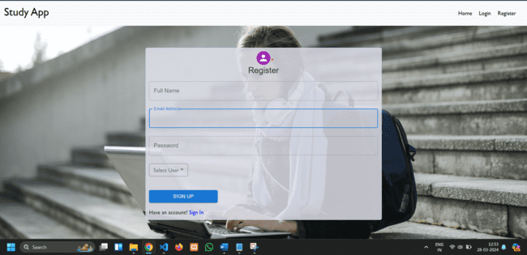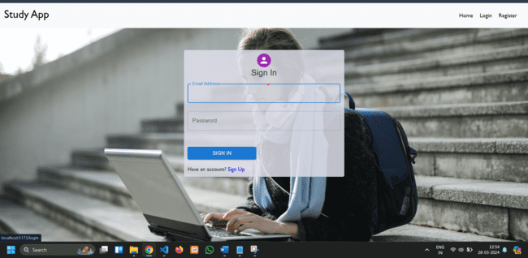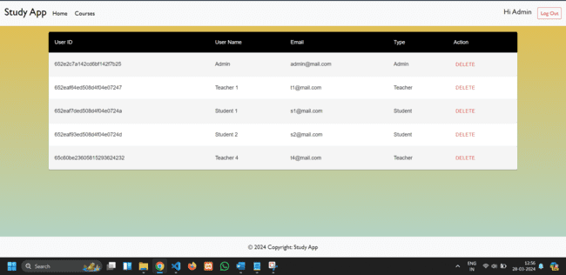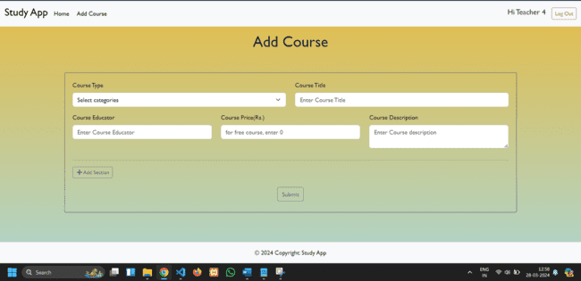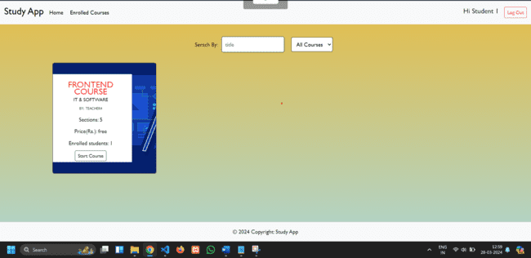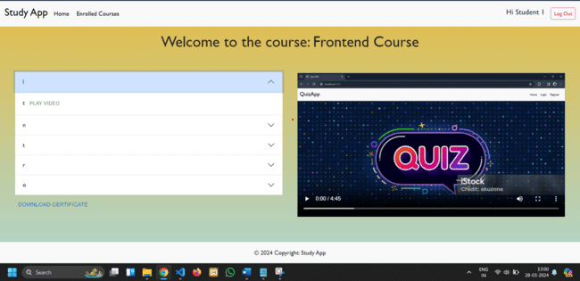

10. Testing
Testing was done using:
- Manual testing for all UI flows
- Postman for API endpoint testing
- Load testing with Apache JMeter

11. Screenshots or Demo
- Github Repository: https://github.com/deepikamukku83/LearnHub-
12. Known Issues
- Live chat is not real-time (refresh needed)
- Some responsiveness issues on small screens

13. Future Enhancements
- Add AI-based course recommendations
- Mobile app version
- Real-time chat and announcements
- Dark/light theme toggle

Appendix A: Ideation Phase – Brainstorm & Idea Prioritization
Team Gathering & Collaboration: Our team initiated the project by organizing a virtual brainstorming session to bring together diverse ideas and explore real-world problems that can be solved through technology. Each member was encouraged to share pain points they personally experienced or observed in their daily lives. The discussion focused on areas such as education, accessibility, and skill development.
Initial Brainstormed Ideas:
- Smart School Attendance System
- Online Learning Platform with Progress Tracking
- College Event Scheduler
- Digital Exam Proctoring Tool
- Career Guidance Portal
Prioritization Criteria:
- Relevance and urgency of the problem
- Feasibility of solution within project timeline
- Technical scope and learning opportunities
- User base and social impact potential
Selected Idea – LearnHub:Your Center for Skill Enhancement:After careful analysis and ranking based on feasibility, scope, and user demand, we finalized our problem statement around the lack of flexible and engaging platforms for self-paced skill development. We selected OLP, a full-stack educational platform, allowing users to browse, enroll, and complete courses while tracking their progress and earning certifications.
This idea resonated with all team members and allowed us to incorporate a variety of technical concepts including React, Node, Express, MongoDB, and JWT authentication, while solving a meaningful educational challenge.

